Allogene Interview Prep Cheat Sheet

Website: Allogene Therapeutics: Allogeneic Cell Therapy
Linkedin: (4) Allogene Therapeutics: Overview | LinkedIn
Interviewer: Kristin Walker | LinkedIn
Video with CEO: https://www.linkedin.com/posts/allogene-therapeutics_making-allogeneic-car-t-a-reality-activity-6808736284102680576-slLc/

Overview
Allogene Therapeutics is a clinical-stage biotechnology company pioneering the development of allogeneic chimeric antigen receptor T cell (AlloCAR T™) therapies for cancer. The goal of our allogeneic cell therapy platform is simple: take the same biological processes that allow the first generation autologous CAR T therapies to deliver breakthrough clinical benefits but eliminate the need to create a personalized therapy for each patient. Instead, we start with T cells from healthy donors, which is intended to allow for creation of inventory for “off-the-shelf” use in patients faster, more reliably, and at greater scale.

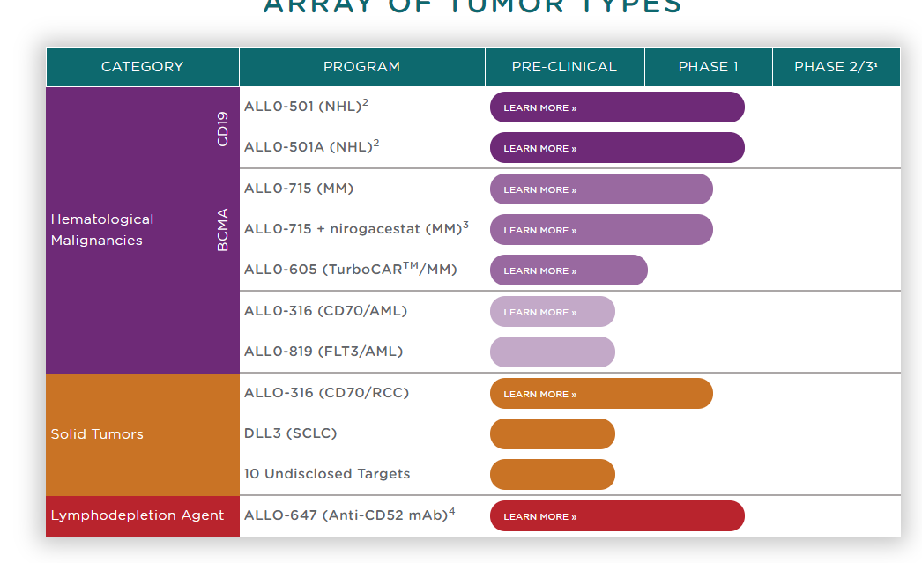

Associate Director/Senior Manager, CDM
Job Description:
Reporting directly to the Head of the Clinical Data Management, the Associate Director or Senior Manager, Clinical Data Management will be responsible for the strategic leadership of the Clinical Data Management unit supporting a specific drug development program. This individual will manage the operational aspects of data management supporting global drug development activities of a program, including the selection and oversight of data management contractors / vendor partners. The position requires a detailed knowledge of Data management platform and software, clinical trial databases, and Pharmaceutical drug development process. The successful candidate will provide direction and guidance to the Clinical development team and will be responsible for supporting end-to-end data management activities for one or more studies.
Responsibilities include, but are not limited to:
- Establish and provide leadership to the Global Data Management team for a product development project at Allogene to set a high performance and collaborative culture
- Provide data management representation and guidance on internal cross-functional clinical teams
- Work collaboratively with internal and external team members to coordinate the planning and execution of day to day data management deliverables
- Provide expertise and guidance to the clinical development team regarding data standards
- Lead a team of high performing clinical data management consultants / vendors to meet business goals
- Effectively interact with senior members in Biometrics for strategic planning to ensure internal standards in accordance with corporate objectives
- Oversee database status with respect to key performance indicators, metrics, and program level deliverables and timelines
- Contribute to project resource planning, re-forecasting, and program deliverable timeline
Position Requirements & Experience:
- Bachelor’s degree (or higher) in Statistics, Computer Science or other closely related field to programming with at least 6 years of clinical/statistical programming experience within pharmaceutical industry and at least 3 years of relevant clinical trial experience.
- Experience implementing Clinical Data Management standards and procedures is required
- Experience in regulatory GCP inspections/audits is a plus
- Demonstrated ability to manage staff that delivers project goals for clinical data management and mentoring junior data managers
- Successfully manage clinical data management vendors, contractors and service providers
- Flexible to changing priorities, and detail-oriented, with initiative to take on unfamiliar tasks
- Demonstrated ability to establish and articulate a plan for a team to ensure appropriate focus and direction
- Good analytical skills and demonstrated experience in gathering, interpreting and analyzing data in clinical research and drug development
- Comfortable in a fast-paced small company environment with minimal direction and able to adjust workload based upon changing priorities
- Candidates must be authorized to work in the U.S.
Notes
- Industry exp. (not from CRO or large pharma). Small Biotech is ideal.
- They will need to do coordinator and data management task. Hands ON!!
- Ideal candidate would have Oncology and immuno oncology exp.
- Hands on exp in medidata/rave.
- Designing CRFs,
- They Outsource programmers.
- Strong knowledge on Oncology
- No management of employees in this role.
- Be willing to travel up to south San Fran.

Past interview feedback
First round interview yesterday: interview went well with Allogene-
Only concern is that they are looking for specific oncology things- asked about response systems/response types which he hadn't worked with.

Other Qs: Tell me about your background, why are you looking to leave, lots of questions on hands-on experience, are you currently hands on (he said no, goes in if they need help- but in previous position was totally hands on)

They only have sr dir one fte and this would be the other fte and they have a contractor starting
sounds like they dont use cro's as much- still up for it! normally wouldn't but for that money, he would!!

*He asked what's financial forecast for company was since they don't have any products? Answer: Their investors are great, what they're working on has good probability of moving forward. Company is two years old; convo centered around his experiences in his jobs. A expressed he's ready to execute any responsibilities that are needed, hands on or otherwise.
"Can you see how hands on he is? When is the last time they did data reconciliation and data review and Is he comfortable issuing queries?"
“asked if this position was mostly hands on? do they outsource anything? told them they outsource programming and have contractors that do data review. told him HR notes that some of this role could be super hands on- to the data coordinator level”
“talk about your background- couple of back and forth questions- felt like she was disinterested- she was barely paying attention to him what version was rave have you used? that's a tricky question 4/2 or 4.4 - just a odd question and odd conversation asked questions on data review tools that he blanked out on very basic nit picky questions”
Super nice team, overall it went great
Was a really long week for T the VP said T would be the perfect fit at Allogene group has 9 deadlines to hit before February
Yayra asked A LOT of questions – T hadn't done a few things, but was confident with most questions - not a bullshitter –
- Sent thank-you letters!

Good questions to potentially ask

You may consider asking the following questions (if you find it appropriate):

(1) Do you have any concerns you would like to discuss? (This will give you the opportunity to address any potential concerns that were not covered during the interview and hopefully will reaffirm your qualifications for the role)

(2) When do you anticipate making a decision?

